Nepal College of Information Technology
Assessment Fall 2010
Program: B.E.CE/ELX Time: 3 hrs
Semester: Fall (I) FM: 100
Subject: Chemistry PM: 50
Attempt all questions

1. a) What are the supporting facts of H-spectra on Bohr's atomic theory? 6
b) Calculate the wave-length of electron of H-atom when it jumps from 6th orbit to Paschen series. (R=1.097373x10⁷m⁻¹) 4
2. a) Expalin how Heisenberg uncertainty principle goes against Bohr's theory. 6
b) What is the significance of Ψ and Ψ² in schroedinger wave equation? 4
3. a) Define Buffer solution. Explain the mechanism of acidic buffer solution. 2+4
b) Calculate the PH of a solution made by mixing 50 ml of 0.01 M Ba 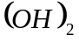 solution with 500ml of water. 4
4. a) Give an account of electrochemical series and its application. 2+4
b) Calculate the emf of the cell:
Zn/Zn⁺⁺ (0.001M) 11 Ag⁺(0.1M)/Ag
The standard electrode potential (E°) of Ag/Ag⁺ is 0.80v and Zn/Zn⁺⁺ is -0.76v. 4
5. a) What do you mean by electronegativity? How is it measured? What are the factors affecting its values? 6
b) Describe the variation of ionization energy along a group and periods in the periodic table with suitable reason. 4
6. a) Explain Metallic bond on the basis of election sea model. 5
b) Write the Lewis structure of the following compounds:
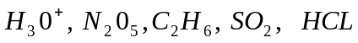 5
7. a) What do you mean by inductive effect? Why is acetic acid weaker acid than formic acid? 3+4
b) Why isopropyl carbocation is less stable than tert-butyl carbocation? 3
8. a) Write the mechanism, kinetics and stereochemistry of 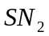 reaction. 5
b) Define enantiomerism and diastereomerism with suitable example. 5
9. a) Predict the major products of the following reactions with suitable reason showing the mechanism
i. 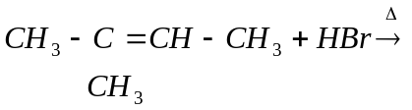……….
ii. 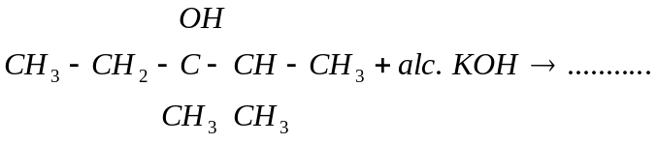
b) Write the structure of following organic compounds:
i. Phenol
ii. Benzoic acid
iii. 4-Nitropent-3-enoic acid
iv. Cyclohex adiene
v. 2, 3-dimethyl but -2-ene
10. Write short notes on any two of the following 5*2=10
a) Arrheniues theory of Ionization
b) Valence bond theory
c) Quantum numbers

